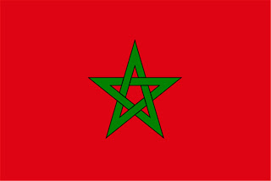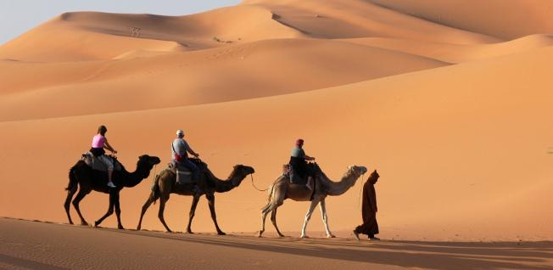**COMPARATIVE STUDY OF AGRICULTURAL AND LIFE SCIENCES IN MOROCCO**

**LEAD FACULTY**

DR. JAMES ANDERSON

**CONTACT**

JENNIFER JONES

jejone18@vt.edu

**ALS 5954 (3 CREDITS; CRN 62167)**

**May 20– June 3, 2017**

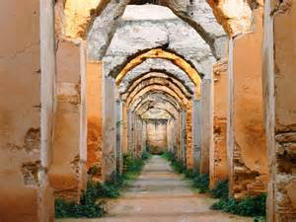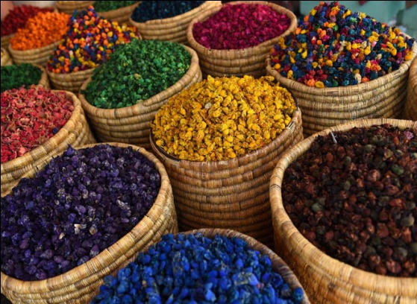

**COURSE GOALS**

* **To provide opportunities for exploration and dialogue on topics related to agricultural and life sciences in Morocco.**
* **To provide an authentic and extensive experience of the historical, geographic, architectural, linguistic, political, economic, and educational complexities of the country.**
* **To guide students in synthesizing findings into a comparative analysis of a selected topic within agricultural and life sciences.**

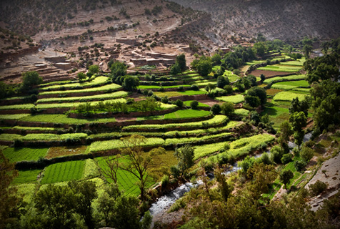

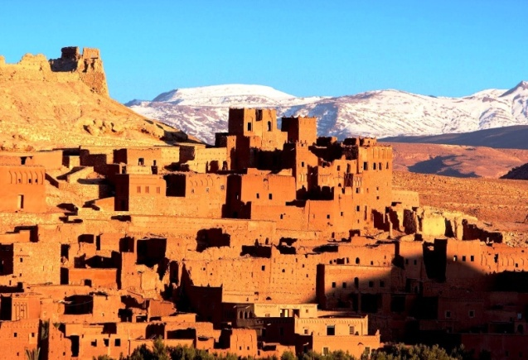

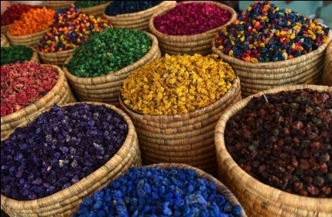

**TOUR STOPS**

CASABLANCA, RABAT, FES, MEKNES, ERRACHIDIA, ERFOUD, MERZOUGA, OUARZAZATE, and MARRAKESH



